Yawn Detector and Counter System

Omeshamisu Anigala  
*Computer Science*  
*South Dakota State University*Brookings SD, U.S.A.  
omeshamisu.anigala@jacks.sdstate.edu

***Abstract*—This project aims to create an easy-use tool for Face reading, Yawn detection and counter.**

***Keywords—Machine vision, Yawn Detector Counter , OpenCV, Computer Vision***

# I. INTRODUCTION

Nature is an intrinsic part of humans and trying to fight nature most of the time could be a herculean task. However, with technology, researchers have found ways to improve the quality of life for people willing to use these cutting-edge inventions.

For this project, I will be focusing particularly on one of the very miniscule behaviors of Humans, Yawning and why being conscious about it seems very trivial but also important.

# II. LITERATURE REVIEW

RELATED WORK

Paul Viola et al. [6] presented an approach for object detection which minimizes computation time while achieving high detection accuracy. The approach was used to construct a face detection system which is approximately 15 faster than any previous approach.

Yoshihiro Takei et al. [6] discussed the method to estimate a driver’s fatigue through steering motion. They applied the Chaos theory to explain the change of steering wheel motion.

Xiao Fan et al. [6] gives to locate and track a driver’s mouth movement using a CCD camera to study on monitoring and recognizing a driver’s yawning and their experiment results show that Gabor coefficients are more powerful than geometric features to detect yawning and the average recognition rate is 95% which has more than 20% improvement.

Xiao Fan et al. [6] gives to locate and track a driver’s mouth movement using a CCD camera to study on monitoring and recognizing a driver’s yawning and their experiment results show that Gabor coefficients are more powerful than geometric features to detect yawning and the average recognition rate is 95% which has more than 20% improvement.

# III. PROBLEM STATEMENT

# WHY YAWN DETECTION?

As humans we tend to ignore or forget how vulnerable our body can be.

Most of the time, if we pay attention our body is always trying to communicate with us.

Humans get busy with life and sometimes get overwhelmed with work and family life and then get behind the wheel. Driving under the influence is not the only causative factor for Accidents, be it auto crash/car crash, plane crash etc. The Human Body communicates but unless one is a doctor or a medical professional it might be difficult trying to understand what our body is trying to tell us and other times we just simply forget how our body functions.

When we forget how our body functions or simply don’t understand what our body is trying to tell us, we tend to run into problems and that is why we have technologies for Blood, sugar and Heart rate monitoring, steps counter to get how many steps one has taken in day, Screen time features on mobile phones like Apple.

Tools like google search could, to a large extent, help with information people need, to understand what our body is trying to tell us but google search is not intuitive and is incapable of sensing the actual human body.

Going to a hospital is also the first point of direction on getting information on our bodies but even medical practitioners understand the herculean task of manually diagnosing a patient and still fall back on technology for the sake of efficiency.

When we yawn is normal but when we excessively do so within close intervals it becomes abnormal, most times we are not conscious of the fact that it is a way our body lets us know something is wrong.

The most common medical problems that are associated with increased yawning are sleep deprivation, insomnia, sleep apnea, narcolepsy, and many medicines that cause sleepiness. There are some other medical diseases that cause yawning including bleeding around the heart, brain tumor, multiple sclerosis, stroke, and even heart attack [1].

When we are exhausted or unwell it is not advisable to carry out certain tasks. Tasks such as driving a car, flying a plane, carrying out a surgical operation are very sensitive tasks and should be done with a clear mind and healthy body.

# IV. METHODOLOGY

RESEARCH

I set out in the beginning to use images to detect if a person was yawning or not by creating a training and validation dataset and using an existing model to train the network, but that would have been inefficient as live detection is the proper way to address the question aforementioned.

DATA (TRANSFER LEARNING)

An already trained model was used to implement this system [2]. Anaconda was installed along with its packages, some of the Conda forge source packages used are Python, OpenCV, Numpy and DLIB.

The python code was run to turn on the laptop’s webcam which in turn brings up a window with the live streaming from the webcam and counts how many times yawns are detected.

Google colab was an option to work on this project but I opted for Jupyter notebook because of easy access to personal system’s webcam through opencv library. Google colab has a different port to access a system’s webcam. It has all the packages installed in it but it was time consuming because it was lagging hence my preference to use jupyter notebook.

# V. CONTRIBUTION

When I set out to carry out this project I realized that adequate documentation of Yawn Detection was not available. So I made proper documentation and created an html document which is on my github pageant the link as the ast reference of this paper.

VI . FUTURE RESEARCH PROSPECTS

I imagine in the future a Yawn detection system that is more intuitive and interactive.

A Yawn detector and counter after reaching a threshold for a driver turns on the trafficator of the vehicle and slows it down and says driver should park and take a rest.

I also envisage a system with a sensor installed on a PC that alerts users to take a break after reaching a maximum threshold for yawing.

VI1. CONCLUSION

To aid individuals seeking to better connect with and manage nature safely, this tool would read a face, detect and count Yawns.

This project will make use of Deep convolutional neural network and will be classified under supervised learning as the input and output is already known., The live video will detect a yawn and keep count of it.

The system was implemented using Jupyter notebook with codes written in Python Programming Language.This tool is able to detect Yawns and count how many times it is done.

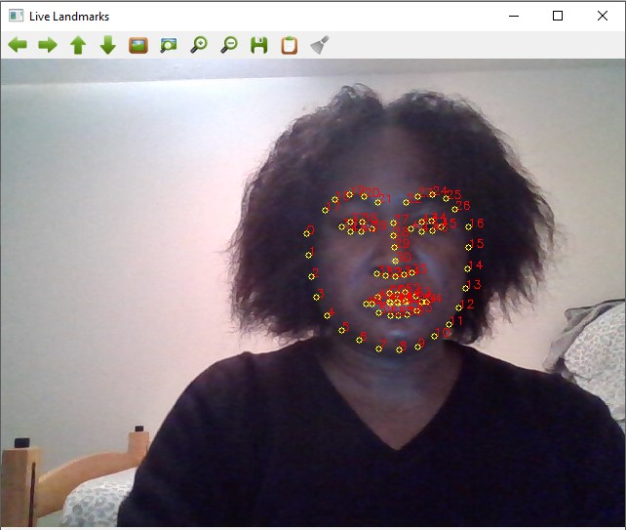

Reference

1. “Yawning: Why & What Could It Mean?” *MUSC Health | Charleston SC*, <https://muschealth.org/medical-services/geriatrics-and-aging/healthy-aging/yawning> .

[2] “Sourceforge.” Dlib C++ Library - Browse /Dlib/v18.10 at SourceForge.net, <https://sourceforge.net/projects/dclib/files/dlib/v18.10/> .

[3] This is the code behind the Switching Eds blog post:

<http://matthewearl.github.io/2015/07/28/switching-eds-with-python/>

[4] Actual Code Nivu, Nivu. “Nivu/Myvino: Face Landmark Detection.” *GitHub*, 11 Mar. 2020, <https://github.com/nivu/myvino> .

[5] Viola, Paul. “Robust Real-Time Object Detection.” *Robust Real-Time Object Detection*, Https://Www.cs.cmu.edu/, 13 July 2001, <https://www.cs.cmu.edu/~efros/courses/lbmv07/papers/viola-ijcv-01.pdf> .

[6] Saradadevi†, Mandalapu. “Driver Fatigue Detection Using Mouth and Yawning Analysis.” *Cite Seerx*, Https://Citeseerx.ist.psu.edu/, 6 June 2008, <https://citeseerx.ist.psu.edu/viewdoc/download?doi=10.1.1.542.1708&rep=rep1&type=pdf> .

[7]Anigala,Omeshamisu. “Omesham/Yawn-Detection-Documentation: Yawn Detection Machine Vision Project.” *GitHub*, GitHub, 1 May 2022, <https://github.com/Omesham/Yawn-Detection-Documentation> .